Cover Art
Mycology of Cannabis

For the cover art we are imagining a diagram of a cannabis plant with zoom-in on specific areas of the plant that shows fungi growth of fungi that grow on that particular area of the plant. E.g.:

- Diagram of mature cannabis plant
- Inflorescence will showed a zoom-in depicting how Budrot can grow in flower clusters
- Zoom in on the roots will show arbuscular mycorrhizae infecting root cells
- Zoom in on plant leaf shows powdery mildew fungi growing on the surface of the leaf tissue
- Zoom in on plant crown (where stem meets the soil) showing crown rot fungi infecting stem and vascular tissue of plant

Below are some diagrams to give you an idea of what we are thinking for the artwork

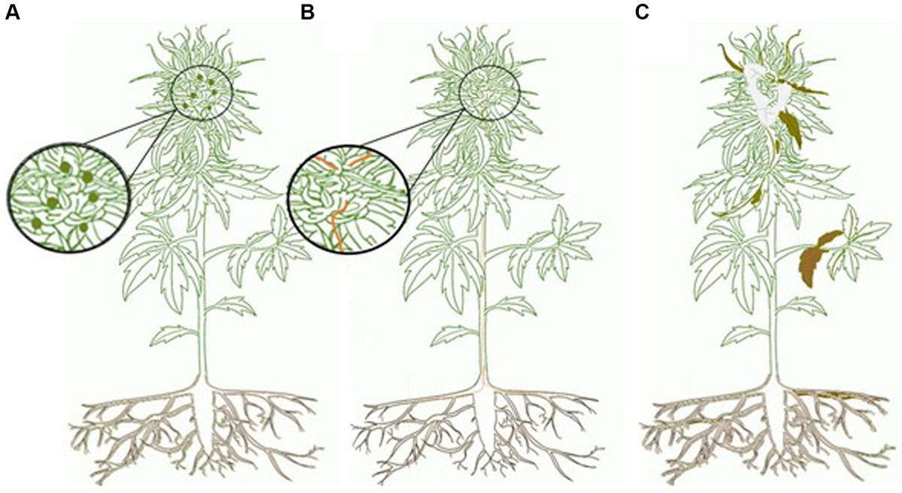
Punja 2021
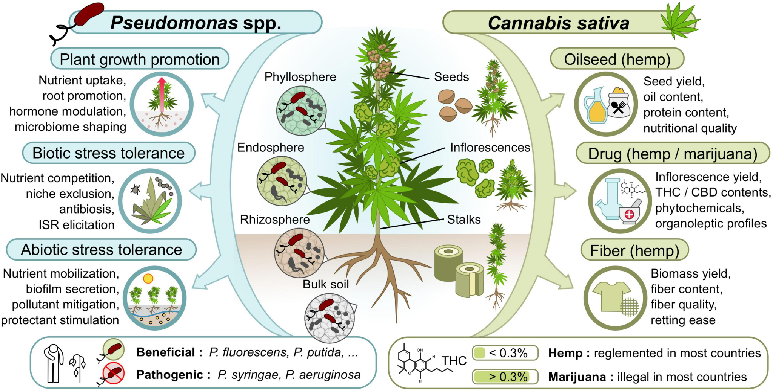
Balthazar et al 2022

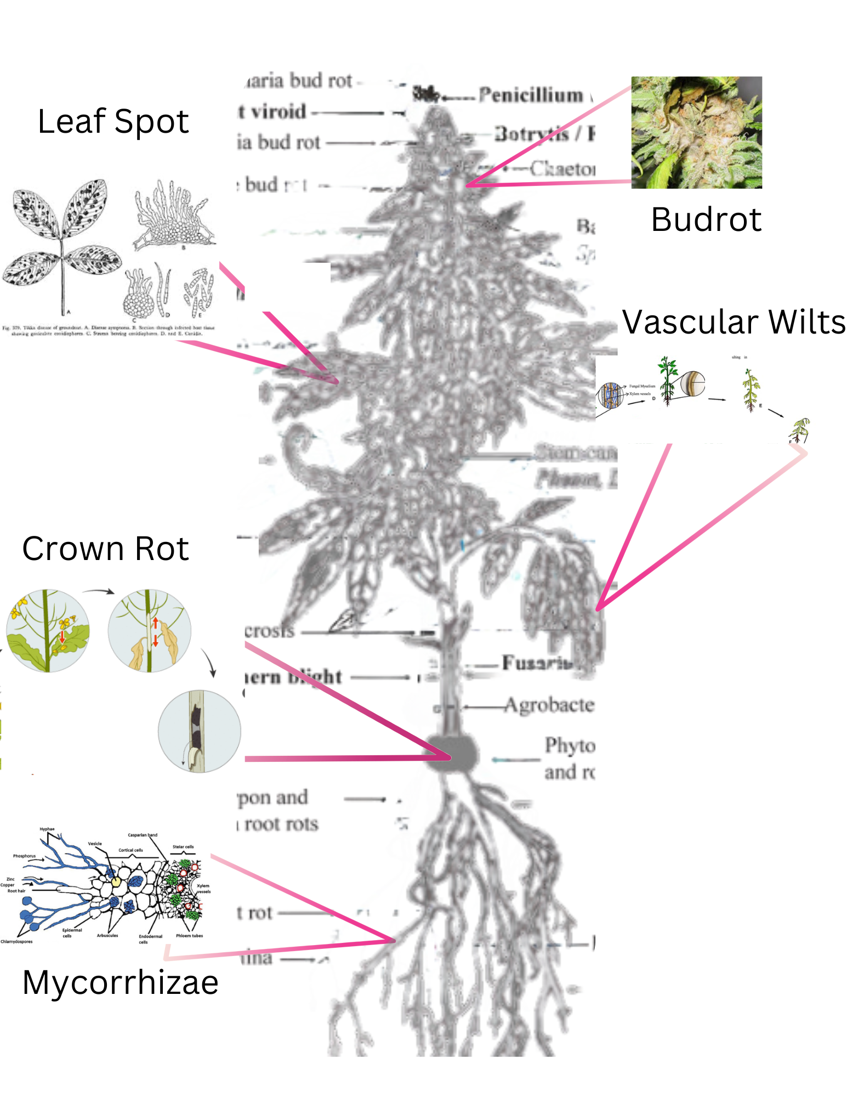
Rough idea of what we are imagining for the cover art

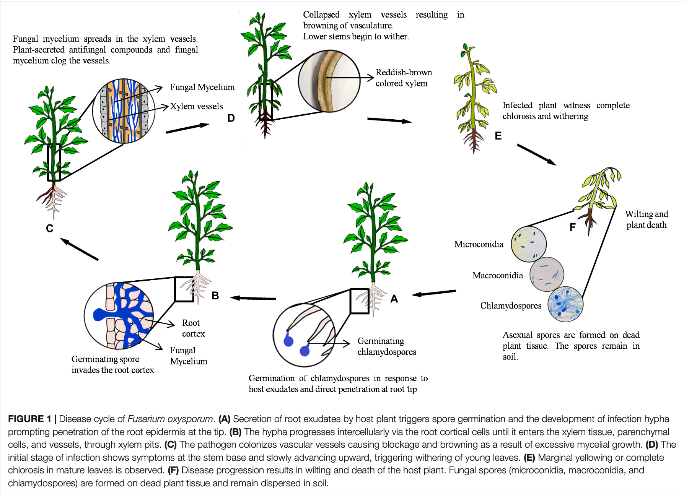

This image shows the ‘zoom-in’ feature that we would like to use for the cover art.

